DATABASE MANAGEMENT SYSTEMS
MINI PROJECT
TOPIC: Online Course Certification System

SUBMITTED BY:
NAME: HARISH THIRUPPATHI
REG NO: 2117230020064
DEPT & SEC: CSE - B
YEAR: 2nd Year
CLASS INSTRUCTOR:
Ms.GETHARA GOWRI
ASSISTANT PROFESSOR
CSE DEPARTMENT

1. Introduction:
An Online Course Certification System manages student enrollments, tracks progress, and issues certificates upon course completion. It ensures smooth administration of online courses by automating registrations, course completion tracking, and certification issuance using SQL.

2. Algorithm:
1️. User Registration – Students and instructors register in the system.
2️. Course Creation – Instructors add courses.
3️. Enrollment – Students enroll in courses.
4️. Completion Check – System verifies course completion.
5️. Certificate Issuance – A certificate is generated if criteria are met.

3. Description:
The system consists of the following tables:
- students – Stores student details.
- instructors – Manages instructors.
- courses – Contains course information.
- enrollments – Tracks student-course relationships.
- certifications – Stores issued certificates.

4. Program (SQL Queries):
Creating Tables & Inserting Data
SQL
CopyEdit
CREATE TABLE students (
student_id INT AUTO_INCREMENT PRIMARY KEY, name VARCHAR(100), email VARCHAR(100) UNIQUE, password VARCHAR(100)
);

CREATE TABLE instructors (
instructor_id INT AUTO_INCREMENT PRIMARY KEY, name VARCHAR(100), email VARCHAR(100) UNIQUE, password VARCHAR(100)
);

CREATE TABLE courses (
course_id INT AUTO_INCREMENT PRIMARY KEY, title VARCHAR(255), description TEXT, instructor_id INT,
FOREIGN KEY (instructor_id) REFERENCES instructors(instructor_id)
);

CREATE TABLE enrollments (
enrollment_id INT AUTO_INCREMENT PRIMARY KEY, student_id INT, course_id INT, status ENUM('In Progress', 'Completed'),
FOREIGN KEY (student_id) REFERENCES students(student_id), FOREIGN KEY (course_id) REFERENCES courses(course_id)
);

CREATE TABLE certifications (
certificate_id INT AUTO_INCREMENT PRIMARY KEY, student_id INT, course_id INT, issue_date TIMESTAMP DEFAULT CURRENT_TIMESTAMP,
FOREIGN KEY (student_id) REFERENCES students(student_id), FOREIGN KEY (course_id) REFERENCES courses(course_id)
);

INSERT INTO students (name, email, password) VALUES ('Alice Johnson', 'alice@example.com', 'password123');
INSERT INTO instructors (name, email, password) VALUES ('Dr. Smith', 'smith@example.com', 'securepass');
INSERT INTO courses (title, description, instructor_id) VALUES ('SQL for Beginners', 'Learn SQL from scratch.', 1);
INSERT INTO enrollments (student_id, course_id, status) VALUES (1, 1, 'In Progress');

UPDATE enrollments SET status = 'Completed' WHERE student_id = 1 AND course_id = 1;
INSERT INTO certifications (student_id, course_id)
SELECT student_id, course_id FROM enrollments WHERE student_id = 1 AND course_id = 1 AND status = 'Completed';

SELECT s.name AS Student, c.title AS Course, cert.issue_date AS Certificate_Issued_On
FROM certifications cert
JOIN students s ON cert.student_id = s.student_id
JOIN courses c ON cert.course_id = c.course_id;

5. Results & Output:
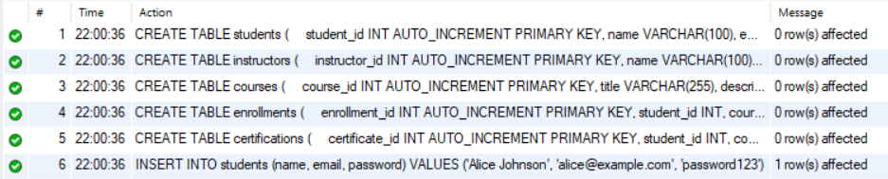

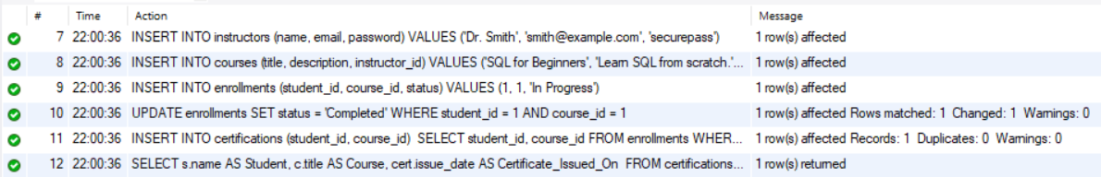

6. Conclusion:
The Online Course Certification System streamlines course management by enabling efficient enrollment, progress tracking, and certification generation. SQL automation eliminates manual tasks, making learning administration seamless. Future improvements may include quiz integration, instructor dashboards, and automated notifications.

